Wireless Network Planning Coverage Analysis in a 3D Urban Outdoor Environment using Ray-Tracing Propagation Model

Simu Calin

Emanuel TRINC

*Abstract*—This electronic document is a “live” template and already defines the components of your paper [title, text, heads, etc.] in its style sheet. *\*CRITICAL: Do Not Use Symbols, Special Characters, Footnotes, or Math in Paper Title or Abstract*. (*Abstract*)

Keywords — Network Planning, Ray Tracing, Wireless Propagation Model

# Introduction

Ray Tracing is probably the most realistic propagation model beginning to be widely used in Wireless Communications nowadays for generating realistic RF channel data. Ray-Tracing simulations in Outdoor 3D environments provide critical insights for deploying and optimizing wireless networks, ensuring reliable and efficient communication services.

The purpose of this paper is to study the received signal strength at cell boundary and in various points inside the cell using Ray Tracing Propagation Model for a VoLTE micro cell (base station) installed in the middle of the Outdoor Urban environment of Manhattan.

In order to perform the simulation for the Ray Tracing in a 3D Urban environment, an RT-based simulator like Simulink MatLab will be used. But, besides the RT simulation tool, there are other RF-channel characteristics to be taken into account as well, the most important for this study being the following:

| RT RF-channel Characteristics | |
| --- | --- |
| Base Station Type | Antenna Type |
| Cell Layout (Shape) Type | Frequency Range |
| Cell Sectorization Type | Cell Power Consumption |

*(Table 1.1)*

**Base Stations Types**. *“Base stations in cellular telephone networks are more commonly referred to as cell towers. Each cellphone connects to the cell tower, which in turn connects it to the wired public switched telephone network (PSTN), the internet or other cellphones within the cell. The size of the base station depends on the size of the area covered, the number of clients supported and the local geography.”* [2].

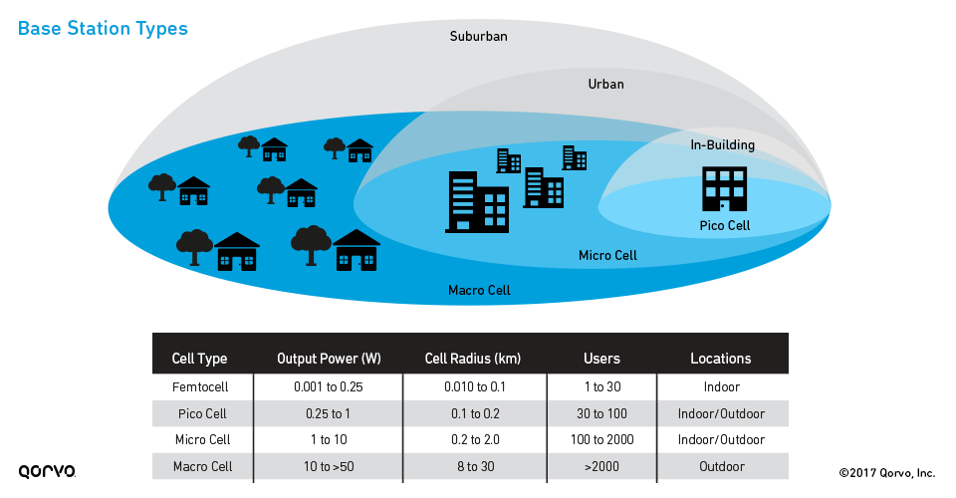

*(Fig. 1.1) Base Stations Types [1]*

**Cell Layout Types**. In wireless cellular networks, hexagonal shaped cells are artificial and cannot be implemented in practice. However this shape is chosen to simplify planning and design of a cellular system, as hexagons fit together without any overlap.

|  | Cell Layout (Shape) Type | |
| --- | --- | --- |
| Shape | Description |
|  | Hexagonal  *(Fictious)* | Cellular System Planning and Design Simplification |
|  | Circular  *(Ideal)* | Ideal Power Coverage Area |
|  | Irregular  *(Real)* | Shape constant changing due to prevailing conditions. |

*(Table 1.2) Cell Layout Type*

**Cell Sectorization**. Technique used in cellular networks to divide the cell into multiple sectors. Each sector is covered by a directional antenna, enabling more efficient use of available spectrum and improving network performance.

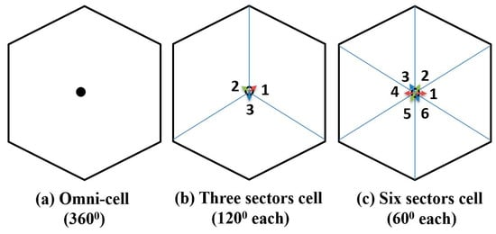

*(Fig. 1.2) Cell Sectorization Types with directional antennas []*

**Antenna Types**. TODO

For the purposes of this study we will make a coverage analysis using Ray Tracing propagation model, for an omni-cell with a ${360}^{°}$ Dipole antenna placed in the center of the cell and radiating in all directions. We will consider the Ideal case of the Cell Layout, which will be implemented using a circular array of 25 dipole antennas placed at various radiuses from the base station in the 3D urban area of Manhattan, which has a lot of very large buildings obstructing the radio waves.

# Related Work

There are not that many 3D simulations of this type with RT for dense urban areas with complex building structures as far as we were able to investigate at the point in time that this paper was written.

# Simulation Environment Setup

The simulation environment is based on Simulink MatLab with Antenna Toolbox installed, so that we will be able to display transmitter/receiver sites, and RF propagation visualizations using Site Viewer window with 3D Globe over Manhattan.

## A. Site Viewer with Customized 3D Buildings

Site Viewer can be customized with 3D buildings and unique building materials as reported by OpenStreetMap. The buildings will be colored according to their materials:

“brick” ⟼ "#AA4A44"

“concrete” ⟼ "#D3D3D3"

“copper” ⟼ "#B87333"

“glass” ⟼ "#35707E"

“metal” ⟼ "#151513"

“plaster” ⟼ "#FFFFFF"

“stone” ⟼ "#301934"

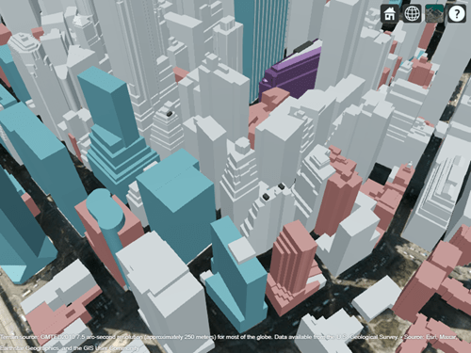

*(Fig. 3.1) 3D Buildings in Manhattan (MatLab)*

## B. Circular Receiver Site Array

As we have seen in the introductory section of this paper, in a real-world scenario, the Wireless Cell Layout is close to a Circular Layout, so for the purposes of this Real-World 3D simulation, we will setup Circular Receiver Arrays at the border of the Wireless Cell so that we can measure various parameters at the border of the planned cell, in order to make the best decision about the best cell radius based on the desired capabilities needed.

These Circular Receiver Arrays can be configured to contain any desired amount of receiver sites, MatLab algorithm will divide equally the provided number of cells in such a way to fit the ${360}^{°}$ of the circle in equal slices and placing each receiver site at exactly the same distance from the Transmitter site, which sits in the center of the Cell.

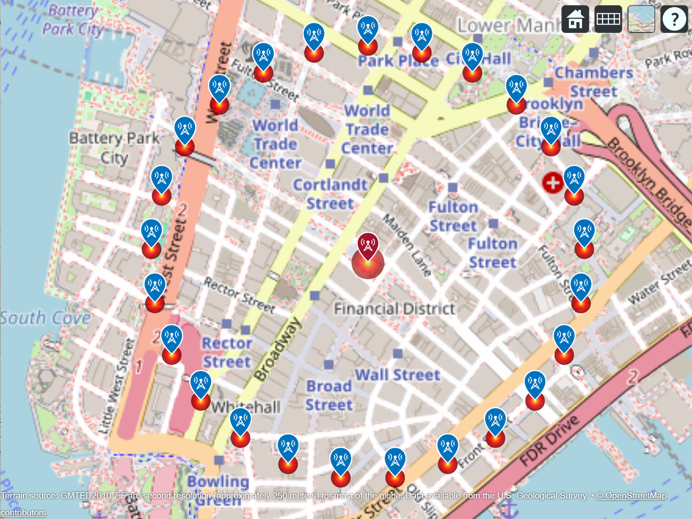

*(Fig. 3.2) 500m radius 25 site Circular Receiver Array in the center of Manhattan*

The 25 site Circular Receiver Array presented in Fig. 3.2 can be overlayed on top of the 3D buildings layer, but in this case we will have some of the receivers on top of high buildings which could influence the analysis result, we just have to be aware of this fact. There is a configuration built-in into the MatLab algorithm that can filter the receivers that are above a certain altitude, if we want to simulate only using ground receivers.

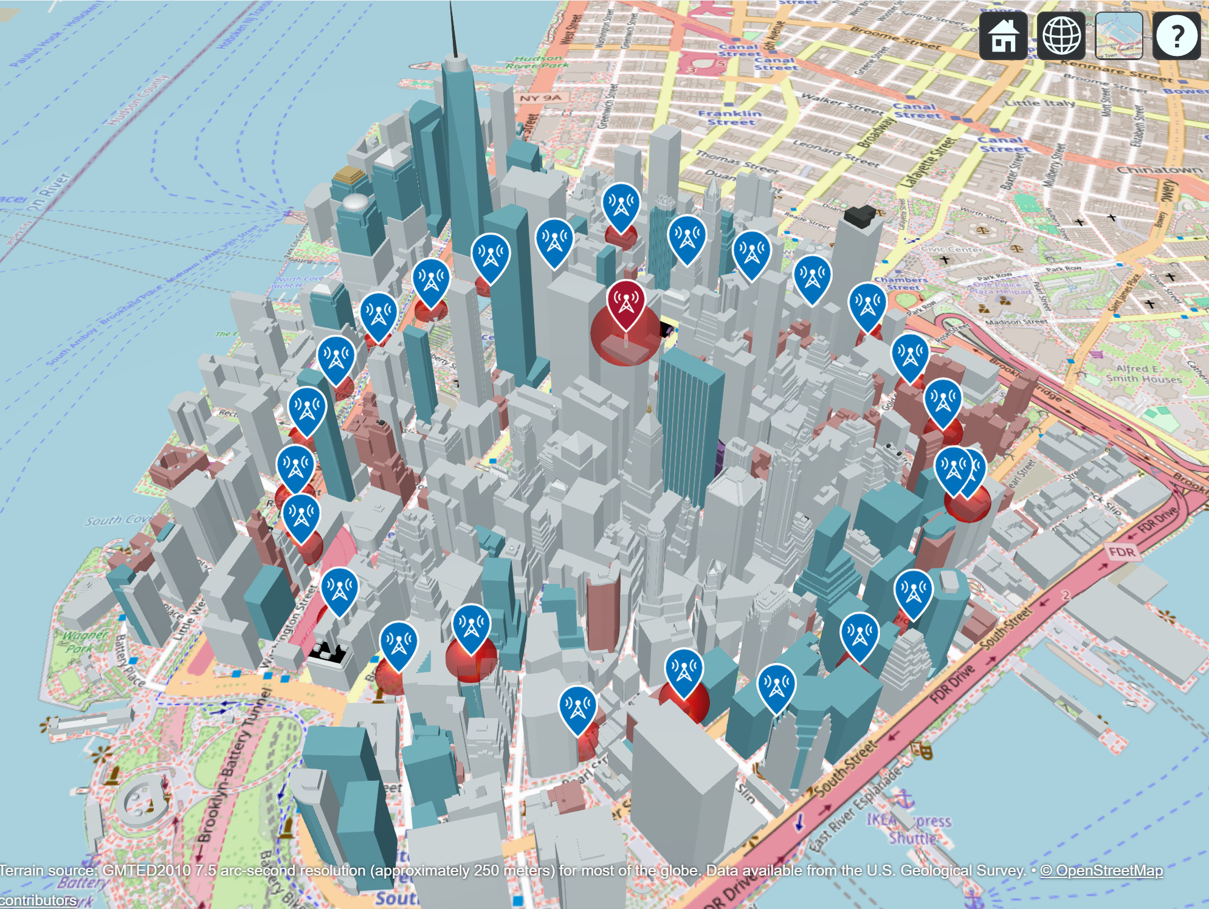

*(Fig. 3.3) 500m radius 25 site Circular Receiver Array overlayed on top of 3D buildings*

# Simulation Results

In this section we will analyze the simulation results for the setup described previously applied in the context of the VoLTE cell with a Dipole transmitter operating at 2600MHz.

VoLTE (Voice over Long-term Evolution) is a technology that allows high-definition (HD) voice communication over 4G LTE networks. Moreover, the connection between 2 terminals is realized faster during a call because VoLTE can use a higher bandwidth.

## A. Cell Radius Analysis

The purpose of the simulation of VoLTE is to make a Microcell RF Coverage Analysis for a 3D urban environment using Ray-Tracing propagation model. The first step of the simulation will be an analysis of what would be the best Cell radius given the cell parameters. To achieve this, a Transmitter site is placed in the middle of the cell and 4 Cell radiuses are considered, 300m, 400m, 500m, and 600m. Table 4.1 presents more detailed about the chosen parameters for the simulation.

| Simulation Parameter | Parameter Value(s) |
| --- | --- |
| Tx Frequency | 2600 MHz |
| Tx Antenna | Dipole |
| Tx Power | 10W |
| Tx Location | $${40.708619}^{°}N, {-74.010000}^{°}W$$ |
| Tx Antenna Height | 15m |
| Rx Sensitivity | -90 dBm |
| Rx Antenna | Dipole |
| Rx Array Size | 25 sites |
| Cell Radius | 300m, 400m, 500m, 600m |
| Propagation Models | Ray Tracing + Heavy Rain (50mm/h) |

*(Table 4.1) VoLTE Simulation Parameters*

The simulation was executed on a Laptop computer with the following configuration: Intel Core i7-1165G7, 2.8GHz (8 CPUs), 16 GB RAM. The simulation took a significant amount of time, since Ray-Tracing is resources-hungry.

The simulation was run 4 times, one time for each Cell Radius and the receiver signal strength results were overlayed in a spider plot for better coverage analysis in order to identify which cell radius would fit best for the given parameters.

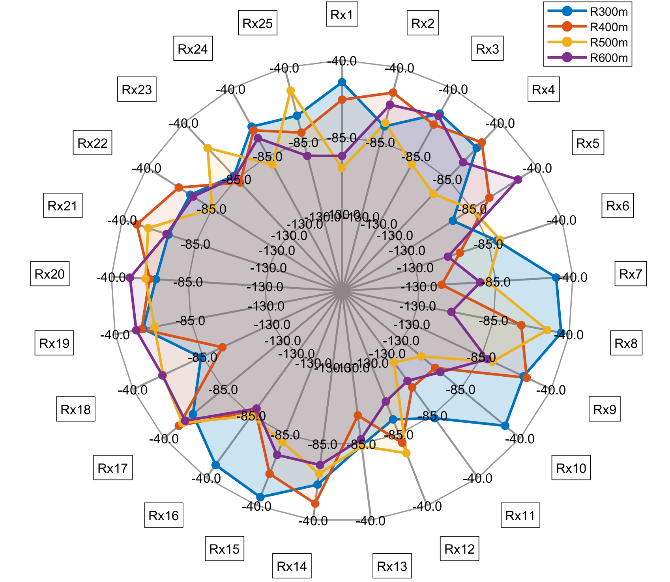

*(Fig. 4.2) MatLab Spider plot of 25 site Receiver Array signal strength of the 4 runs (numbers represent dBm)*

Analyzing the spider plot obtained gives us some interesting insights already. We can observe that in the NE and SE regions of the spider plot, which corresponds to the NE and SE regions of Manhattan, in the region of [Rx5 Rx6] and [Rx11 Rx12 Rx13] respectively, the building bodies getting in front of the receivers seem to be cause a more degradation of the received signal level compared to other directions of the map. This is some very useful information that can be used as input for the Network Planning.

The second fact we can observe by analyzing closely the coverage map obtained in the spider plot from Fig. 4.2, is the coverage areas for various cell radiuses considered. For 300m radius for example can observe that we have the biggest area in the spider plot, progressively decreasing for 400m, 500m, and 600m, as expected, since the signal strength is decreasing due to atmospheric effects as well.

## B. 3D Ray-Tracing Analysis over Manhattan

The spider plot was just a first high-level analysis of the best cell radius distance given the parameters. The next step would be to choose which Cell radius would fit the best given the frequency and power we have chosen for the cell and do a further analysis to also display the ray-tracing rays in Site Viewer and analyze the ray propagation paths in the 3D environment.

Going further we will consider the chosen Cell radius to be 500m. We can then proceed to run the Ray-Tracing analysis using the cell and Ray-Tracing configuration as shown below in the table 4.2.

| Simulation Parameter | Parameter Value(s) |
| --- | --- |
| Cell Radius | 500m |
| RT Method | SBR |
| RT MaxNumReflections | 1 |
| RT MaxNumDiffractions | 1 |

*(Table 4.2) VoLTE 500m Cell RT Simulation Parameters*

The MatLab algorithm constructed specifically for the purposes of this study was executed on the same HW as mentioned before, and after a long execution time we were able to finally see all the rays generated from the Base Station towards all 25 receivers placed in a Circular Array. A snapshot can be seen in Fig. 4.3 and a table with detailed data can be seen in Table 4.3.

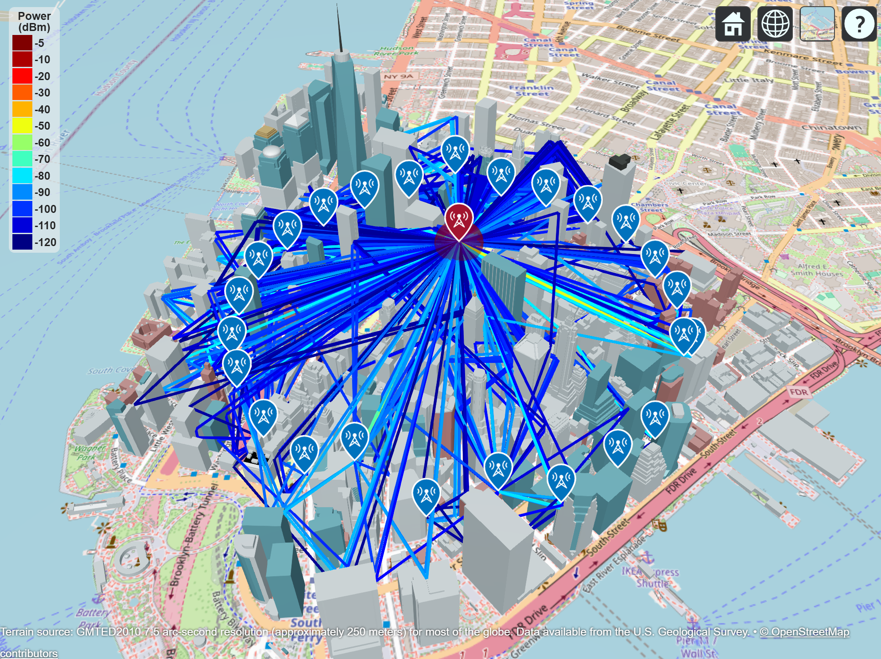

*(Fig. 4.3) RT for 500m radius Circular Receiver Array Layout*

| Rx | Table Column Head | | |
| --- | --- | --- | --- |
| Ray-Tracing [dBm] | RT+Rain [dBm] | Delta [dBm] |
| location pin icon. location pin sign. blue location pin symbol. Map pointer  Icon. 7388581 Vector Art at Vecteezy Rx1 | -123.39 | -123.42 | 1.5 |
| location pin icon. location pin sign. blue location pin symbol. Map pointer  Icon. 7388581 Vector Art at Vecteezy Rx2 | -73.54 | -73.55 | 1.3 |
| location pin icon. location pin sign. blue location pin symbol. Map pointer  Icon. 7388581 Vector Art at Vecteezy Rx3 | -90.41 | -90.42 | 1.2 |
| location pin icon. location pin sign. blue location pin symbol. Map pointer  Icon. 7388581 Vector Art at Vecteezy Rx… | … | … | … |
| location pin icon. location pin sign. blue location pin symbol. Map pointer  Icon. 7388581 Vector Art at Vecteezy Rx24 | -90.69 | -90.70 |  |
| location pin icon. location pin sign. blue location pin symbol. Map pointer  Icon. 7388581 Vector Art at Vecteezy Rx25 | -53.54 | -53.95 |  |

*(Table 4.3)*

Site Viewer can now be analyzed in more detail to observe the way the ray tracing is generating the RF rays to reach each particular receiver and various patterns can be obtained, based on system parameters and 3D simulation environment chosen for the analysis. The most important things related to RT that were observed during the simulations were the following:

* Signal strength received below the receiver sensitivity is received by Rx1.
* Below -120dBm, MatLab refuses to generate a ray. This didn’t happened for 500m radius, but happened for a few receivers for higher readiuses (in the spiderplot such cases were assigned a value of -130dBm).

One last thing we can do for the analysis in this section (section B) is to generate a chart from the results obtained and presented in table 4.3. The chart is presented in Fig. 4.4 and we can analyze which receivers signal strength fall below the value -90dB set for the Receiver Sensitivity. They are highlighted with red in table 4.3.

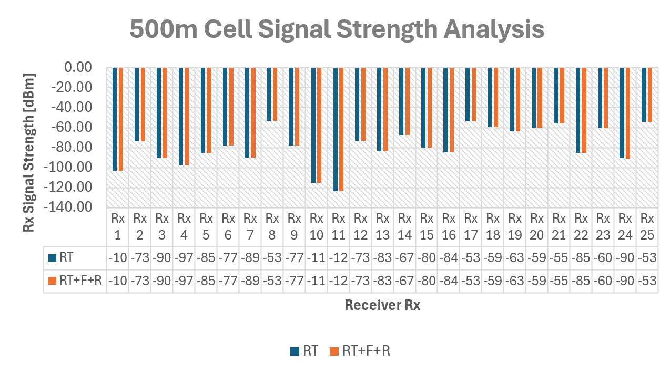

*(Fig. 4.4) 500m Cell Signal Strength Analysis*

## C. Machine Learning Analysis inside the Cell

In the previous section we analyzed the signal strength received at the border of the cell with an array of circular receiver sites. But what if we want to analyze what is happening inside the cell? More specifically, we want to analyze the signal strength in more detail for all the users residing in every location inside the cell.

There are probably several ways to do that, but the most modern and straightforward way to do it is to of course build a MatLab script to automatically place receivers 5-10 meters apart in every ground location inside the cell and analyze the signal strength in detail. But in a 500m radius cell it means we will have to place thousands of receiver sites and process huge amount of data. Luckily, we can generate that amount of data with MatLab, save it in CSV files for later processing with Machine Learning algorithms.

So, the first step is to create a MatLab script to gather all this data from the simulation and save it to a CSV file. But we have to first identify/define what data we want to collect. In ML we need to collect some features and outcomes for each receiver site, and table below presents in more detail the kind of features and outcomes that we can collect for later analysis.

TODO table

After defining the features and outcomes table, we have to implement the MatLab algorithm to setup the simulation environment and collect all this data.

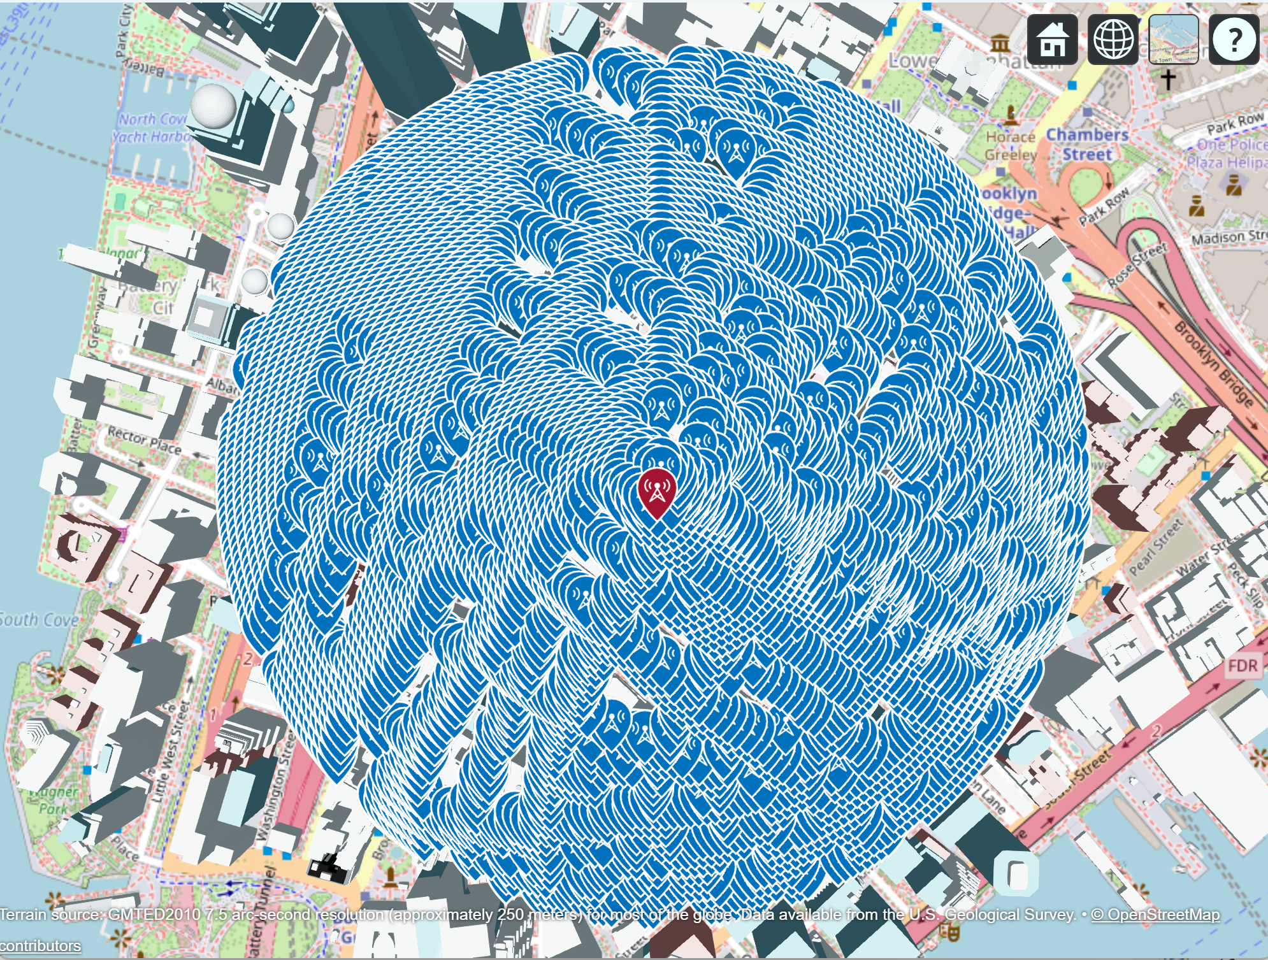*(Fig. 4.4) 8006 Receivers 10m apart generated inside 500m radius Cell at ground level (35m max altitude)*

##### Acknowledgment *(Heading 5)*

The preferred spelling of the word “acknowledgment” in America is without an “e” after the “g”. Avoid the stilted expression “one of us (R. B. G.) thanks ...”. Instead, try “R. B. G. thanks...”. Put sponsor acknowledgments in the unnumbered footnote on the first page.

##### References

1. Small Cell Networks and the Evolution of 5G (Part 1), quorvo.com. [](https://www.qorvo.com/design-hub/blog/small-cell-networks-and-the-evolution-of-5g)
2. Base station definition, techtarget.com. [](https://www.techtarget.com/whatis/definition/base-station)
3. Hexagonal vs Circular Cell Shape: A Comparative Analysis and Evaluation of the Two Popular Modelling Approximations, K. B. Baltzis, 2011. [](https://www.researchgate.net/publication/221912601_Hexagonal_vs_Circular_Cell_Shape_A_Comparative_Analysis_and_Evaluation_of_the_Two_Popular_Modeling_Approximations)
4. Z. Liu, P. Zhao, Three-Dimensional Ray-Tracing-Based Propagation Prediction Model for Microcellular Environment at Sub-6 GHz Frequencies, 2024. [](https://www.mdpi.com/2079-9292/13/8/1451)
5. F. Fuschini, E. M. Vitucci, Ray Tracing Propagation modeling for future small-cell and indoor applications: A review of current techniques, University of Bologna, Italy, 2015. [](https://agupubs.onlinelibrary.wiley.com/doi/epdf/10.1002/2015RS005659)
6. S. Hussain, C. Brennan, An efficient ray tracing method for propagation prediction along a mobile route in urban environments. [](https://agupubs.onlinelibrary.wiley.com/doi/epdf/10.1002/2017RS006275)
7. T. K. Geok, F. Hossain, A Comprehensive Review of Efficient Ray-Tracing Techniques for Wireless Communication, 2018. [](https://www.researchgate.net/publication/325914256_A_Comprehensive_Review_of_Efficient_Ray-Tracing_Techniques_for_Wireless_Communication)
8. <https://dl.acm.org/doi/10.1145/3479242.3487318>
9. <https://arxiv.org/pdf/2303.11103.pdf>
10. MatLab raytrace(), <https://fr.mathworks.com/help/antenna/ref/txsite.raytrace.html>
11. Urban Link and Coverage Analysis using Ray Tracing, MatLab, <https://fr.mathworks.com/help/comm/ug/urban-channel-link-analysis-and-visualization-using-ray-tracing.html>
12. <https://www.telecomhall.net/t/what-is-the-difference-of-macro-micro-and-picocells-in-wireless-telecommunications/25555>

TODO – Machine Learning Analysis